Exhibit 1: Front Cover
 | 1cm  2cm  1.5cm | 4 cm
High Efficiency Polymerization of |  | Master’s(Doctoral) Thesis
2.5cm
High Efficiency Polymerization of Synthetic Fibers
2010 |  | Sung Sil Kim (Name in Korean)  Department of Chemical Engineering  Pohang University of Science and Technology  2010
 |  | 6mm
 | 2.5cm
 | 1.5cm

* Paper size: 185mm×255mm
* Font: Myeongjo, Sinmyeongjo, Batang, or Gulim font for Korean, and Arial,
Times New Roman, or similar font for English
* Font Size: Title 21pt, Others 16pt
* Year: Enter the year of graduation
Exhibit 2 : Title Page
(Title in Korean)

High Efficiency Polymerization of Synthetic Fibers
* Font Size: Title 21pt (for both Korean & English)

Exhibit 3: Approval for Submission of Thesis/Dissertation

High Efficiency Polymerization of Synthetic Fibers

by

○ ○ ○ (Name of Student)
Department of ○ ○ ○ ○ (○ ○ ○ program)
Pohang University of Science and Technology

A thesis/dissertation submitted to the faculty of Pohang University of Science
and Technology in partial fulfillment of the requirements for the degree
of Master of Science [Doctor of Philosophy (Doctoral)] in the Department of
○ ○ ○ (○ ○ ○ program)

Pohang, Korea
○. ○. 20 ○○
Approved by
○ ○ ○ (Signature)
Academic Advisor
* Font Size: Title 21pt, Others 14pt
* Date: Enter the date signed
* Refer to Exhibit 13 for the department names.

Exhibit 4: Certificate of Approval for Final Thesis/Dissertation Defense
Thesis Title

Sung Sil Kim

The undersigned have examined this thesis/dissertation and hereby certify that it is worthy of acceptance for a master's/doctoral degree from POSTECH

MM/DD/YYYY

Committee Chair ○ ○ ○ (Seal)
Member ○ ○ ○ (Seal)
Member ○ ○ ○ (Seal)
Member ○ ○ ○ (Seal)
Member ○ ○ ○ (Seal)

* Font Size: Title 21pt, Name 16pt, Others 14pt
* Three seals required for master's and five seals required for doctoral degree
* Date: Enter the approval date of the final defense for the submitted thesis/dissertation
Exhibit 5: Abstract

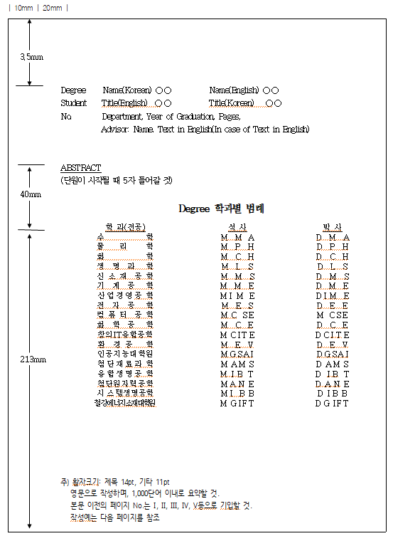
(Enter 5 spaces at the beginning of the paragraph.)
Abbreviation by Department Dept.Department
Name of Dept. Dept.Department
Doctor
Master
* Font size: Title 14pt, Others 11pt
* Written in English, and less than 1,000 words
* The pages before the main body should be numbered I, II, III, IV, V, etc.
* Refer to the next page for an example.
Exhibit 6: Example of an Abstract Page
MCH “Korean Name” Sung Sil Kim,
20010001 High Efficiency Polymerization of Synthetic Fibers.
Title in Korean,
Department of Chemistry, 2009, 108P, Advisor: Chul Su Kim
Text in English.(if the main content is in English)

ABSTRACT

* Your given name should be followed by your family name.

Exhibit 7: Example of a Table of Contents
Contents

- I. Introduction ………………………………………………………………….1

II. Literature survey ……………………………………………………………4

2.1 ……………………………………………………………………………4

2.2 ……………………………………………………………………………5

III. Experimental ……………………………………………………………….6

3.1 ……………………………………………………………………………6

3.2 ……………………………………………………………………………7

3.3 …………………………………………………………………………...11

3.4 ……………………………………………………………………………12

3.5 ……………………………………………………………………………12

* Make sure to number your contents correctly.
* Font Size: Title 14pt
Others 11pt

Exhibit 8: Main Body
I. Introduction

II. Literature survey

III. Experimental

* Font Size: Title 14pt, others 11pt (footnote: 9~10pt)
* Margins: Top 20, Bottom 15, Header 15, Footer 15, Left 25, Right 25
* Page number: Bottom-center of the page, and insert a hyphen (-) on both sides of the number
* Line spacing of 170 or more, set width of 100, and letter spacing of 0
Exhibit 9: Summary in Korean
요 약 문

* Font Size: Title 14pt, Others 11pt
* Written in Korean.

Exhibit 10: References
REFERENCES

- Baker, K.P., Dixon, p., Magazine, M/I. and Silver, E.A. “An algorithm for the dynamic lot sizing problem with time varying production capacity constraints.”
Management Science, Vol.24, No.16, 1978, PP.1710-1720.

2. Bahl, H.C., “Column generation based heuristic algorithm for multi- item scheduling,”
IIE, Vol.15, No2, 1983. Pp.136-141.

3. Bahl, H.C. and Ritzman, L.P. “A cyclic scheduling heuristics for lot sizing with capacity constraints, International Journal of Production Research, Vol.No.2, 1984, pp. 791-800”
* Font Size: Title 14pt, Others 11pt

Exhibit 11: Acknowledgements
Acknowledgements

* Font Size: Title 14pt, Others 11pt

Exhibit 12: Curriculum Vitae
Curriculum Vitae

Name :

Education

1990~1994 ………………………………………………………………(B.S.)
1994~1996 ………………………………………………………………(M.S.)
1996~2000 ………………………………………………………………(Ph.D.)

Experience

1996.3~2000 ………………………………………………………….

Affiliation
…………………………………………………………………………………………

…………………………………………………………………………………………
* Font Size: Title 14pt, Others 11pt
* It is prohibited to disclose information beyond the above categories for protection of personal information.
Exhibit 13: List of Department (Program) Names

- Department of ~ (~program)
- Mathematics
- Physics
- Chemistry
- Life Sciences
- Materials Science and Engineering
- Mechanical Engineering
- Industrial and Management Engineering
- Electrical Engineering
- Computer Science and Engineering
- Chemical Engineering
- Creative IT Engineering
- Division of Environmental Science and Engineering
- Graduate School of Artificial Intelligence
- Division of ~ (~program)
- Advanced Materials Science
- Integrative Biosciences & Biotechnology
- Advanced Nuclear Engineering
- Social Data Science
- Graduate Institute of Ferrous & Energy Materials Technology

